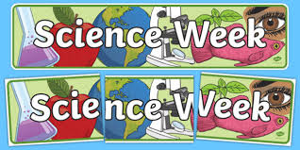

Students from 1st - 6th year at Nenagh College, enjoyed a host of activities and experiences for Science Week 2020 including: table quizzes, videos & workshops, a range of demonstrations, Biodiversity walks, spring bulb planting, and a Biodiversity Photo Competition coordinated by Ms. Hannigan, interactive virtual talks on: How to build an Iron Man Suit and The Science and Engineering of Medical Imaging & Radiotherapy.

